Name: DangNhi Ngoc Ngo

Student ID: 01553277

Class: Database I

**HOMEWORK #1**

**Exercise 2.2.1:**

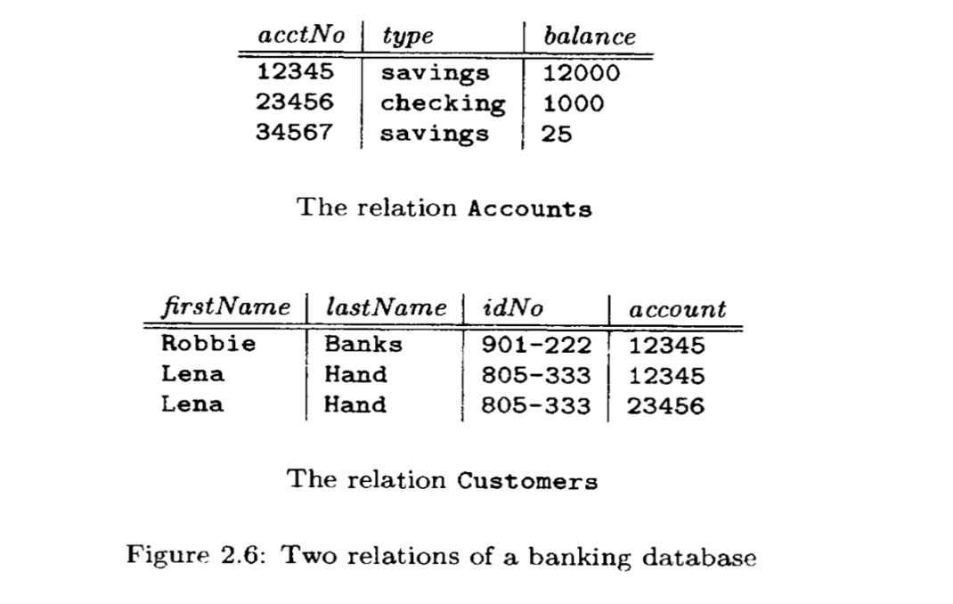

a/ The attributes of each relation:

- The relation Accounts: The attributes are acctNo, type, balance

- The relation Customers: The attributes are firstName, lastName, idNo, account

b/ The tuples of each relation:

- The relation Accounts:

First tuple: (12345, savings, 12000)

Second tuple: (23456, checking, 1000)

Third tuple: (34567, savings, 25)

- The relation Customers:

First tuple: (Robbie, Banks, 901-222, 12345)

Second tuple: (Lena, Hand, 805-333, 12345)

Third tuple: (Lena, Hand, 805-333, 23456)

c/ The components of one tuple from each relation:

- The relation Accounts:

Components of first tuple: 123456, savings, 12000

- The relation Customers:

Components of first tuple: Robbie, Banks, 901-222, 12345

d/ The relation schema for each relation: consists of a relation name and a set of attributes

- The relation Accounts:

Accounts(acctNo, type, balance)

- The relation Customers:

Customers(firstName, lastName, idNo, account)

e/ The database schema: is the set of all relation schemas in the database

Accounts(

acctNo: integer,

type: string,

balance: integer

)

Customers(

firstName: string,

lastName: string,

idNo: string,

account: integer

)

f/ A suitable domain for each attribute

- The relation Accounts:

Accounts(acctNo:integer, type:string, balance:integer)

- The relation Customers:

Customers(firstName:string, lastName:string, idNo:integer, account:integer)

g/ Another equivalent way to present each relation

- The relation Accounts:

|  |  |  |
| --- | --- | --- |
| acctNo | balance | type |
| 34567 | 25 | savings |
| 23456 | 1000 | checking |
| 12345 | 12000 | savings |

- The relation Customers:

|  |  |  |  |
| --- | --- | --- | --- |
| account | idNo | firstName | lastName |
| 12345 | 901-222 | Robbie | Banks |
| 12345 | 805-333 | Lena | Hand |
| 23456 | 805-333 | Lena | Hand |

**Exercise 2.3.1**

The database schema consists of four relations, whose schemas are:

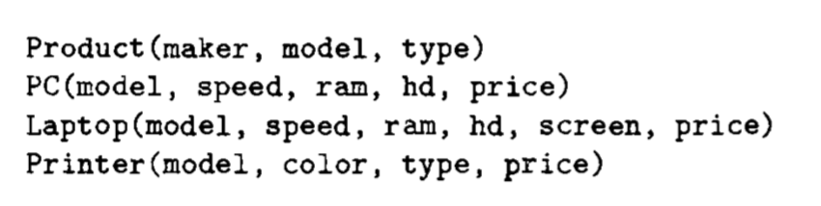

a/ A suitable schema for relation Product

CREATE TABLE Product (

maker VARCHAR(50),

model INT PRIMARY KEY,

type VARCHAR(25)

);

b/ A suitable schema for relation PC

CREATE TABLE PC (

model INT PRIMARY KEY,

speed FLOAT,

ram FLOAT,

hd FLOAT,

price FLOAT

);

c/ A suitable schema for relation Laptop

CREATE TABLE Laptop (

model INT PRIMARY KEY,

speed FLOAT,

ram FLOAT,

hd FLOAT,

screen FLOAT,

price FLOAT

);

d/ A suitable schema for relation Printer

CREATE TABLE Printer (

model INT PRIMARY KEY,

color BOOLEAN,

type VARCHAR(25),

price FLOAT

);

e/ An alteration to your Printer schema from (d) to delete the attribute color

ALTER TABLE Printer DROP color;

f/ An alteration to your Laptop schema from (c) to add the attribute od (optical-disk type, e.g., cd or dvd). Let the default value for this attribute be ‘none’ if the laptop does not have an optical dish

ALTER TABLE Laptop ADD od VARCHAR(25) DEFAULT ‘none’